**Worksheet-2.2**

**Student Name:-** Pushpraj Roy **UID:-** 20BCS9866

**Branch:-** BE- CSE **Section/Group:-** WM_617 “A”

**Subjetct Code:-** 20CSP-317 **Semester:-** 5th

**Subject Name:-** Machine Learning Lab

1. **Aim/Overview of the practical: -**

To implement Naive Bayes algorithm.

1. **Task to be done/ Which logistics used:-**

To prepare a model with Naive Bayes algorithm.

1. **Source Code:-**

# importing the libraries import numpy as np import matplotlib.pyplot as plt import pandas as pd

import seaborn as sns

# importing the dataset dataset = pd.read_csv('NaiveBayes.csv')

# split the data into inputs and outputs X = dataset.iloc[:, [0,1]].values

y = dataset.iloc[:, 2].values

|  |
| --- |
| # training and testing data from sklearn.model_selection import train_test_split    # assign test data size 25%  X_train, X_test, y_train, y_test =train_test_split(X,y,test_size= 0.25, random_state=  0) |

#importing standard scaler

from sklearn.preprocessing import StandardScaler

|  |
| --- |
| # scalling the input data sc_X = StandardScaler()  X_train = sc_X.fit_transform(X_train)  X_test = sc_X.fit_transform(X_test) |

|  |
| --- |
| # importing classifier from sklearn.naive_bayes import BernoulliNB    # initializaing the NB classifer = BernoulliNB()    # training the model classifer.fit(X_train, y_train)    # testing the model y_pred = classifer.predict(X_test) |

# importing accuracy score from sklearn.metrics import accuracy_score

# printing the accuracy of the model

print(accuracy_score(y_pred, y_test))

# import Gaussian Naive Bayes classifier from sklearn.naive_bayes import GaussianNB

# create a Gaussian Classifier classifer1 = GaussianNB()

# training the model classifer1.fit(X_train, y_train)

# testing the model y_pred1 = classifer1.predict(X_test) # importing accuracy score from sklearn.metrics import accuracy_score

# printing the accuracy of the model

print(accuracy_score(y_test,y_pred1))

|  |
| --- |
| # importing the required modules import seaborn as sns from sklearn.metrics import confusion_matrix    # passing actual and predicted values cm = confusion_matrix(y_test, y_pred)    # true write data values in each cell of the matrix sns.heatmap(cm, annot=True) plt.savefig('confusion.png') |

# importing classification report from sklearn.metrics import classification_report

# printing the report

print(classification_report(y_test, y_pred))

|  |
| --- |
| # importing the required modules import seaborn as sns from sklearn.metrics import confusion_matrix    # passing actual and predicted values cm = confusion_matrix(y_test, y_pred1)    # true write data values in each cell of the matrix sns.heatmap(cm,annot=True) plt.savefig('confusion.png') |

# importing classification report

from sklearn.metrics import classification_report

# printing the report

print(classification_report(y_test, y_pred1))

# assigning features and label variables weather = ['Sunny','Sunny','Overcast','Rainy','Rainy','Rainy','Overcast','Sunny','Sun ny', 'Rainy','Sunny','Overcast','Overcast','Rainy']

# output class

play = ['No','No','Yes','Yes','Yes','No','Yes','No','Yes','Yes','Yes','Yes','Yes','No ']

|  |
| --- |
| # Import LabelEncoder from sklearn import preprocessing    # creating LabelEncoder labelCode = preprocessing.LabelEncoder()    # Converting string labels into numbers.  wheather_encoded=labelCode.fit_transform(weather) |

#Printing the encoded values

print(wheather_encoded)

|  |
| --- |
| # import LabelEncoder from sklearn import preprocessing    # creating LabelEncoder labelCode = preprocessing.LabelEncoder()    # converting string labels into numbers.  label=labelCode.fit_transform(play) |

|  |
| --- |
| # importing numpy module import numpy as np    # converting 1D array to 2D weather_2d = np.reshape(wheather_encoded, (-1, 1)) |

|  |
| --- |
| # import Gaussian Naive Bayes model from sklearn.naive_bayes import GaussianNB    # create a Gaussian Classifier model = GaussianNB()    # train the model using the training sets model.fit(weather_2d, label) |

# predicting the odel predicted= model.predict([[0]]) # 0:Overcast

# printing predicted value print(predicted)

**3. Result/Output**

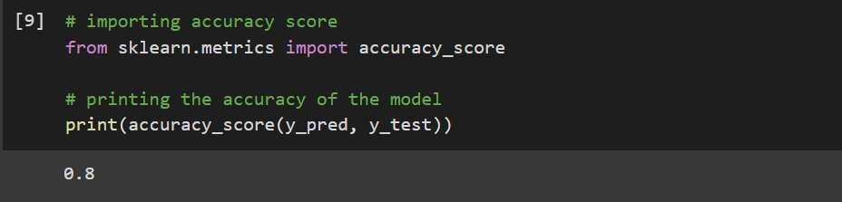

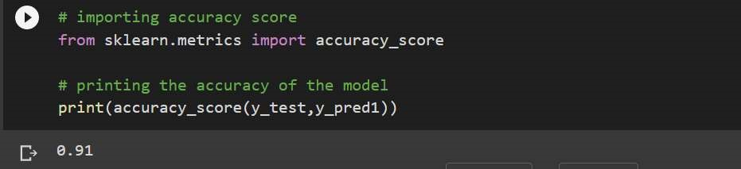

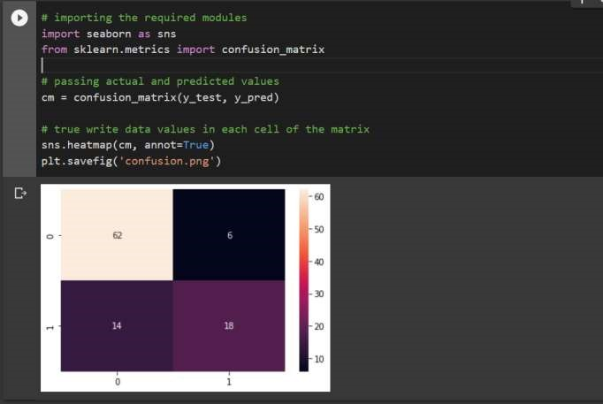

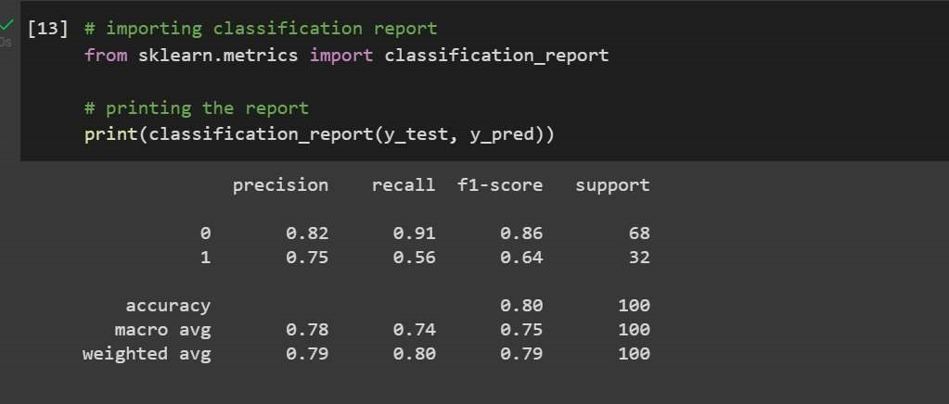

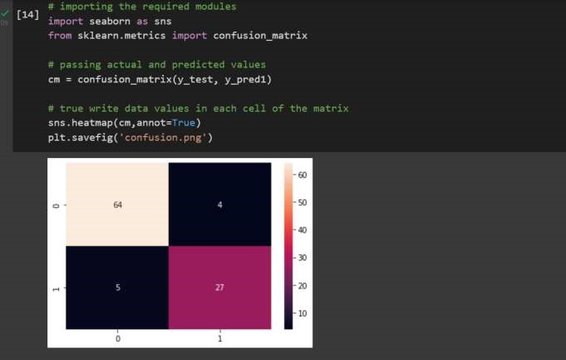

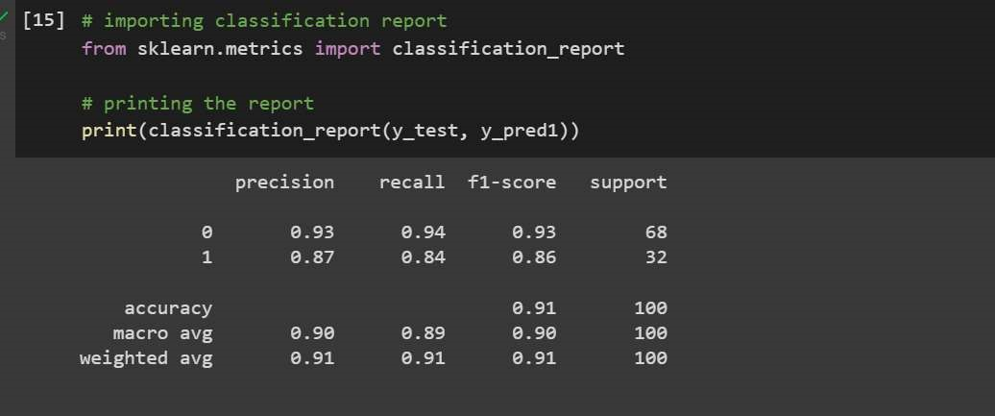

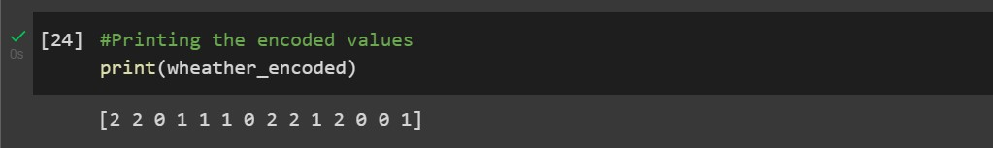

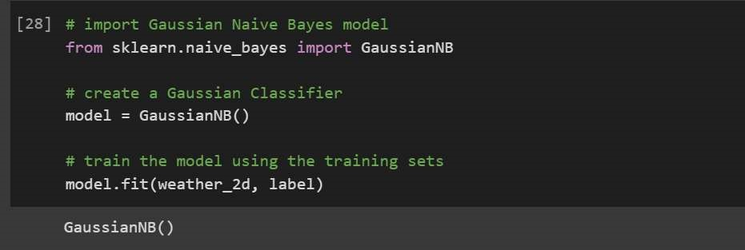

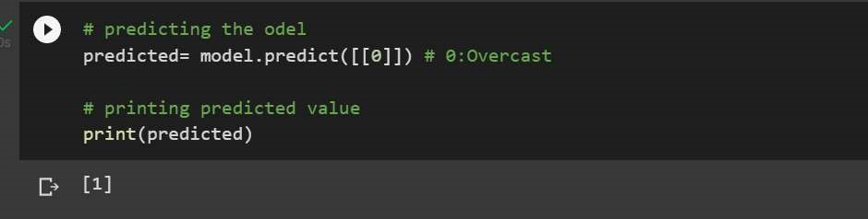

**Learning outcomes (What I have learnt):**

1. Understanding of Exploratory Navies Byes.
2. Able to analyze different Navies Byes with the help of python and pandas library.
3. Learning about different library/packages of python.
4. Learning about the different methods, that are needed to analyze the given dataset.
5. Learning of different Machine Learning Functions